Course Name: Programming in Java Code: PRJ238913
Sem: III
Program: Information Technology

Academic Term: 27 June 2024 to 18 October 2024

SAP ID: 57508240026
Roll No. T023

Mini Project Title: Faculty Feedback SystemThe Faculty Feedback System is a Java-based application integrated with MySQL that automates the process of collecting and analyzing student feedback for faculty members.
Traditionally, feedback collection was manual and inefficient, involving paper-based forms that were difficult to manage and analyze. This project digitalizes the entire workflow — enabling students to log in securely, rate their teachers and subjects, and automatically store the data in a centralized database.
The system uses object-oriented programming concepts such as abstraction, inheritance, and exception handling, ensuring modularity and robustness. Each Head of Department (HOD) can log in to view average ratings of faculty members across semesters, displayed using JFreeChart as bar charts (for faculty performance) and pie charts (to show rated vs. unrated students).This project not only streamlines the feedback process but also provides visual insights that help HODs identify areas of improvement and maintain teaching quality across all departments.

Features of the Mini Project

Student Sign-Up and Login:Students can securely register and log in with a unique username containing at least one special character.

The system automatically identifies the student’s department and semester based on login credentials.

Secure Database Integration (MySQL + JDBC):

All data (students, teachers, subjects, and ratings) are stored and managed using MySQL with JDBC connectivity.

Supports relational mapping between teachers and subjects across semesters.

Automated Teacher and Subject Listing:

Students see only the teachers and subjects relevant to their department and semester.

Teachers can teach multiple semesters, and subjects are dynamically displayed based on the semester.

Teacher Feedback and Rating System:

Students can rate teachers on a scale of 1 to 5.

Prevents duplicate feedback entries and allows updating existing ratings.

Head of Department (HOD) Portal:

Secure HOD login for each department with unique credentials.

Displays bar charts showing average faculty ratings per semester.

Displays pie charts showing the percentage of students who have and haven’t submitted feedback.

Graphical Analytics (JFreeChart Integration):

Uses JFreeChart to generate visual charts for performance analysis.

Provides intuitive, data-driven insights for faculty evaluation.

Error Handling and Validation:

Implements custom exceptions (InvalidUsernameException) to ensure proper username format.

Handles SQL exceptions, invalid inputs, and connection issues gracefully.

Object-Oriented and Modular Design:

Built using principles of inheritance and abstraction through the User, Student, and HOD classes.

Easy to extend for new departments or features like comment-based feedback or PDF reports.

User-Friendly Interface:

Combines console-based menus for interaction and GUI windows (Swing + JFreeChart) for visual reports.

Simple navigation and intuitive flow for both students and HODs.

Software Used

1. JDK 18 (Java Development Kit)
- Description:
JDK (Java Development Kit) 18 is a software development environment used for developing Java applications. It provides tools for compiling (javac), running (java), and debugging Java programs.
- Role in Project:
Used to compile and run the FacultyFeedbackSystemManager.java program. It supports modern Java features, ensuring smooth database connectivity and GUI rendering.

2. Sublime Text 3
- Description:
Sublime Text 3 is a lightweight and powerful text editor widely used for coding. It supports syntax highlighting, quick navigation, and an easy-to-use interface.
- Role in Project:
Used as the IDE (Integrated Development Environment) to write and edit Java source code. Its simplicity and performance make it ideal for small-to-medium-sized Java projects.

3. MySQL Database
- Description:
MySQL is an open-source relational database management system used to store and manage structured data.
- Role in Project:
Used to store data such as student records, teacher details, and feedback ratings. The project connects to the MySQL database using JDBC.

4. Third-Party Libraries

a) jfreechart-1.0.19.jar
- Description:
JFreeChart is an open-source chart library for Java that allows developers to create professional-quality charts easily.
- Role in Project:
Used to generate bar charts that visually display average teacher ratings based on student feedback.

b) jcommon-1.0.23.jar
- Description:
JCommon is a supporting library for JFreeChart that provides general-purpose classes such as utilities, data handling, and configuration management.
- Role in Project:
Works as a dependency for JFreeChart to handle chart rendering, dataset management, and GUI integration.
- Role(Pie Chart)
- Creates a pie chart which analyzes which student has filled the feedback form and who has not.

5. MySQL Connector/J (mysql-connector-java-5.1.48.jar)
- Description:
MySQL Connector/J is an official JDBC driver for connecting Java applications to MySQL databases.
- Role in Project:
Enables the Faculty Feedback System to connect with the MySQL database to insert, update, and retrieve data.
Data Flow Diagram (DFD) Level 0 :
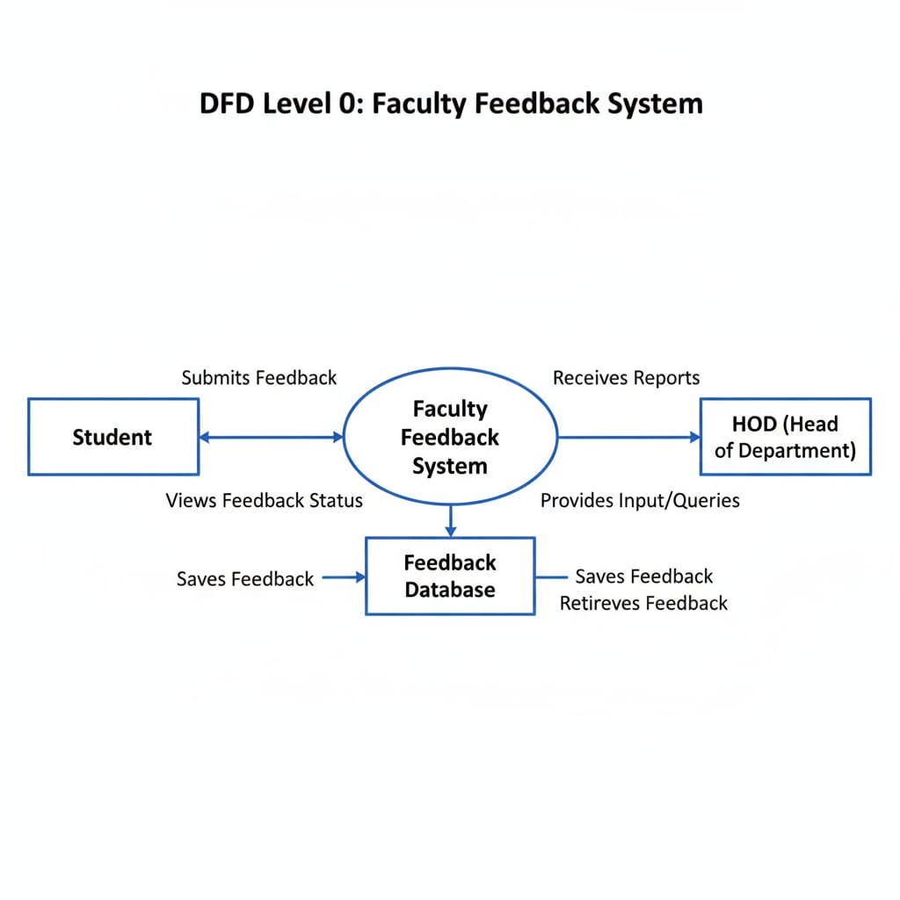
Data Flow Diagram(DFD) level 1 :

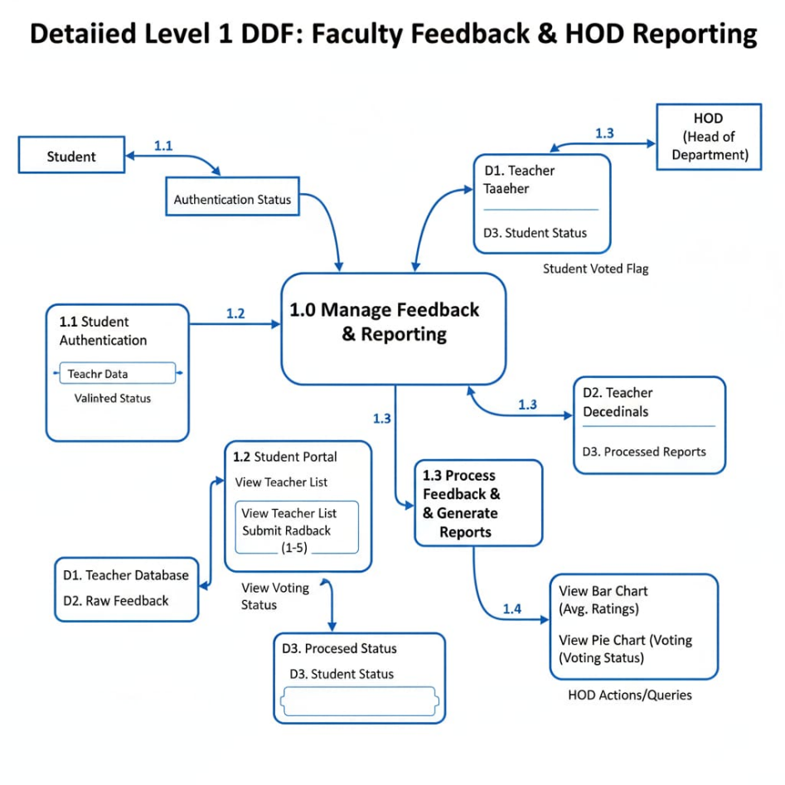
Data Flow Diagram(DFD) level 2
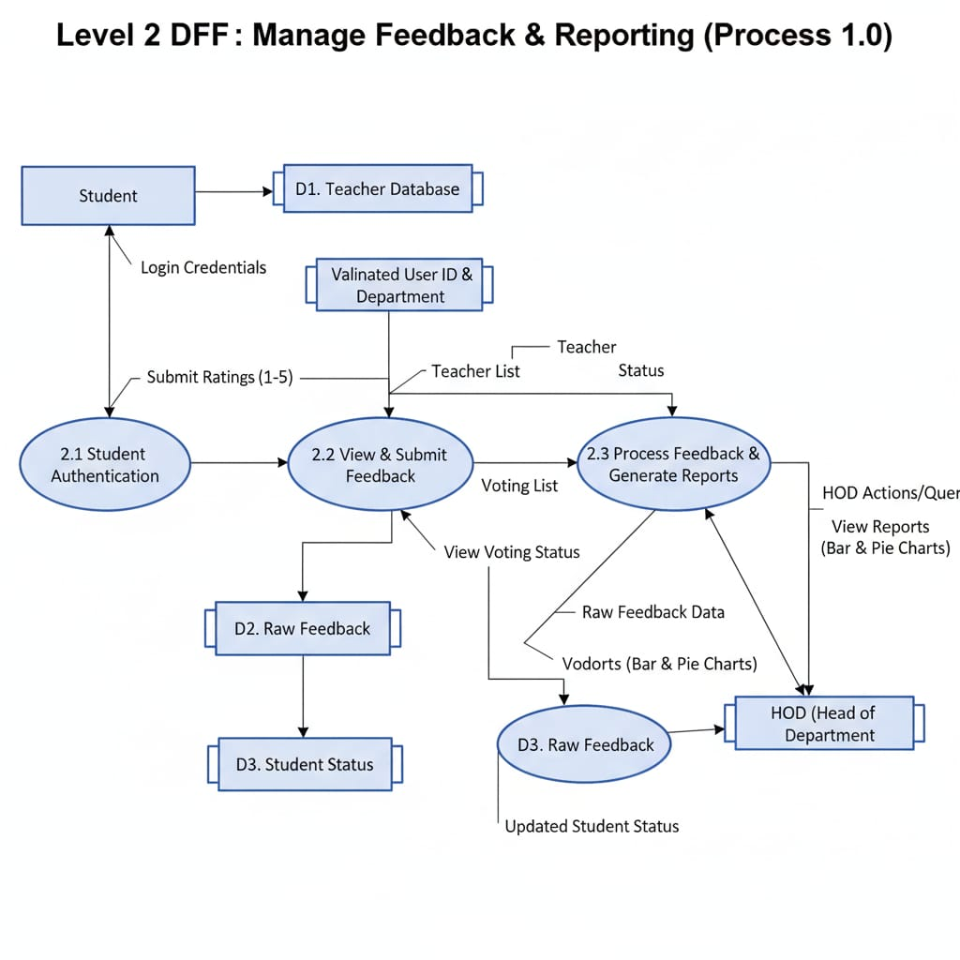

Flow Chart :
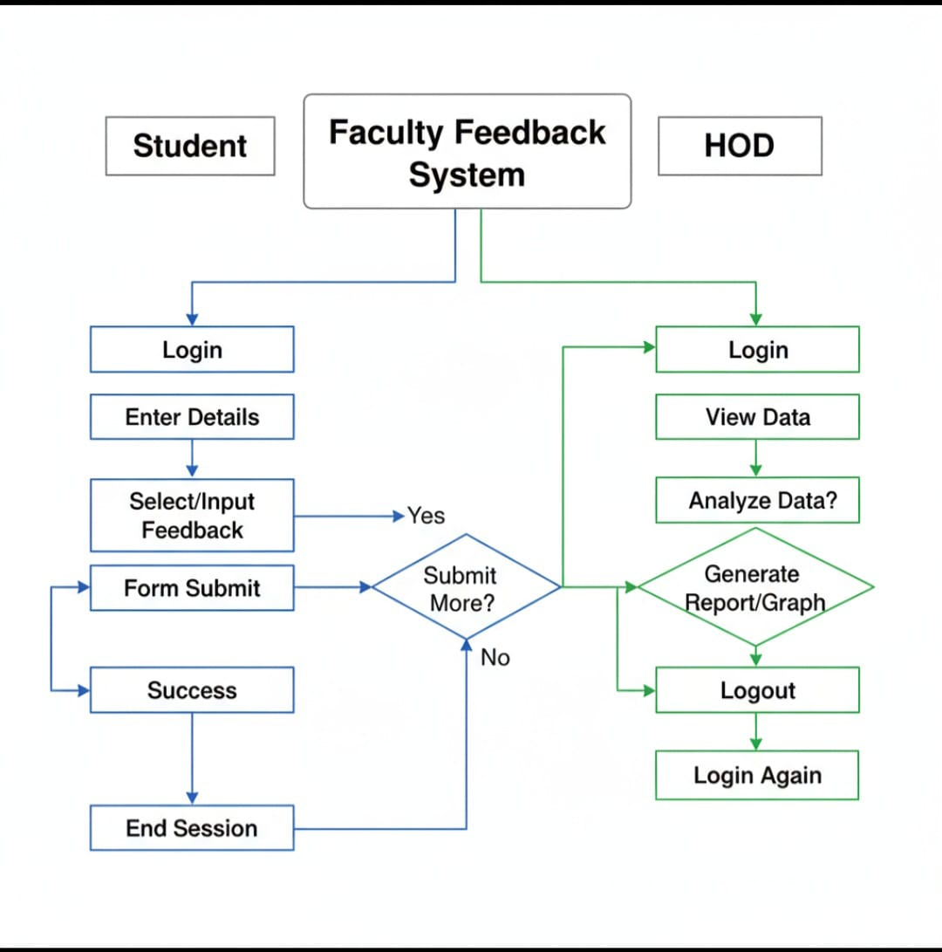

ER Diagram :
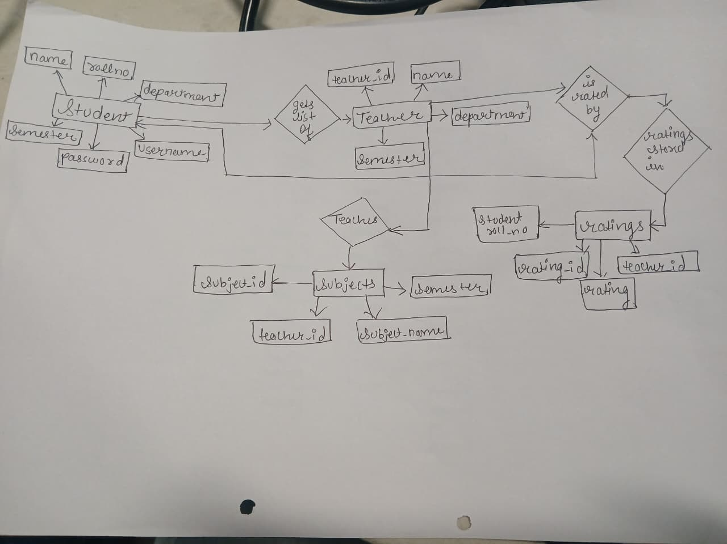
- Modules/Functions Implementation Planning

Sr. No. | Module Name | Description | Implementation Duration
1 | Signup and Login | Allows user to signup/login into the system | 2 days from 20-07-25 to 27-07-25
2 | Student Module | Allows the student to change the password , enter the semester and rate the teacher out of 5. | 15 days from 28-07-25 to 15-08-25
3 | HOD Module | Allows the HOD to login with username and password and choose semester to show Barchart and PieChart. | 15 days from 16-08-25 to 30-08-25
4 | Bar Chart Creation | Creates the Bar chart consisting of Average Rating of Teachers of respective department and Semester | 7 days from 01-09-25 to 07-09-25
5 | Pie Chart Creation | Creates the Pie chart consisting of data of students who have voted and students who have not of respective semester and department | 7 days from 08-09-25 to 14-09-25

Gant Chart :
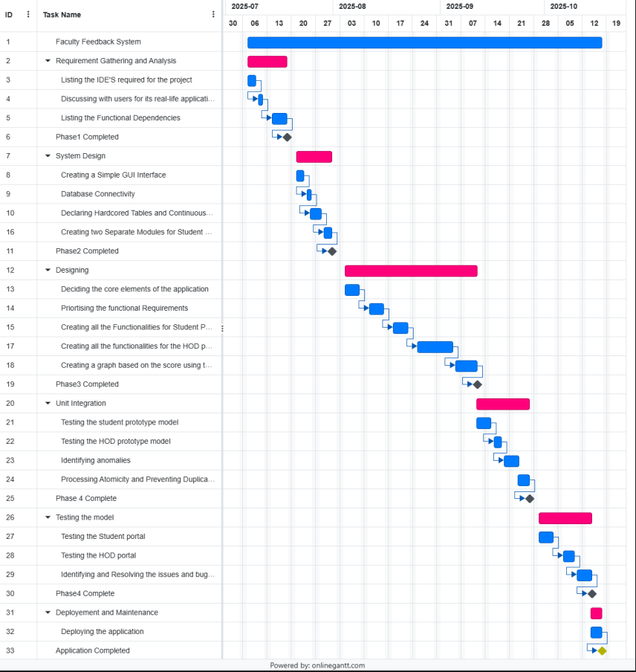
SOURCE CODE :
this is the final java code
import java.sql.*;
import java.util.Scanner;
import javax.swing.*;
import org.jfree.chart.*;
import org.jfree.chart.plot.*;
import org.jfree.chart.renderer.category.BarRenderer;
import org.jfree.data.category.DefaultCategoryDataset;
import org.jfree.data.general.DefaultPieDataset;
import java.awt.Color;
import java.io.*;
// ====================== PASSWORD MASK ======================
class PasswordMask {
public static String readPassword(String prompt) {
System.out.print(prompt);
StringBuilder password = new StringBuilder();
try {
while (true) {
int chInt = System.in.read();
if (chInt == -1) break;
char ch = (char) chInt;
if (ch == '\r' || ch == '\n') {
System.out.println();
break;} else {
password.append(ch);
System.out.print('*');}}
} catch (IOException e) {
e.printStackTrace();}
return password.toString();}}
// ====================== CUSTOM EXCEPTION ======================
class InvalidUsernameException extends Exception {
public String toString() {
return "Invalid Username! Must include at least one special symbol (e.g. $, _, @).";}}
// ====================== ABSTRACT CLASS ======================
abstract class User {
String username;
String password;
public User(String username, String password) {
this.username = username;
this.password = password; }
abstract void login();}
// ====================== STUDENT CLASS ======================
class Student extends User {
Connection con;
int rollNo, semester;
String name, department;
Student(String username, String password) {
super(username, password);
try {
con = DriverManager.getConnection(
jdbc:mysql://localhost:3306/feedback_system?useSSL=false&allowPublicKeyRetrieval=true",
"root", "rishik@12345");} catch (Exception e) {
System.out.println("Database connection failed: " + e);}}
// ---------- SIGNUP ----------
public void signUp() {
Scanner sc = FacultyFeedbackSystemManager.sc;
try {
System.out.print("Enter name: ");
name = sc.nextLine();
System.out.print("Enter department: ");
department = sc.nextLine();
System.out.print("Enter roll number: ");
rollNo = sc.nextInt();
System.out.print("Enter semester (1-6): ");
semester = sc.nextInt();
sc.nextLine();
System.out.print("Enter username: ");
username = sc.nextLine();
if (!username.contains("$") && !username.contains("_") && !username.contains("@")) {
throw new InvalidUsernameException();}
password = PasswordMask.readPassword("Enter password: ");
PreparedStatement ps = con.prepareStatement(
"INSERT INTO students_data(name, department, roll_no, semester, username, password) VALUES (?,?,?,?,?,?)");
ps.setString(1, name);
ps.setString(2, department);
ps.setInt(3, rollNo);
ps.setInt(4, semester);
ps.setString(5, username);
ps.setString(6, password);
ps.executeUpdate();
System.out.println("Sign-up successful! You can now login.");
login();
} catch (InvalidUsernameException e) {
System.out.println("Exception: " + e);
} catch (SQLIntegrityConstraintViolationException e) {
System.out.println("Roll number or username already exists!");
} catch (Exception e) {
System.out.println("Error during sign up: " + e);}}
// ---------- LOGIN ----------
public void login() {
Scanner sc = FacultyFeedbackSystemManager.sc;
try {
System.out.print("Enter username: ");
username = sc.next();
password = PasswordMask.readPassword("Enter password: ");
PreparedStatement ps = con.prepareStatement(
"SELECT * FROM students_data WHERE username=? AND password=?");
ps.setString(1, username);
ps.setString(2, password);
ResultSet rs = ps.executeQuery();
if (rs.next()) {
rollNo = rs.getInt("roll_no");
name = rs.getString("name");
department = rs.getString("department");
semester = rs.getInt("semester");
System.out.println("\nLogin successful!");
System.out.println("Welcome " + name + " (" + department + " - Sem " + semester + ")");
boolean exit = false;
do {
System.out.println("\n--- Student Menu ---");
System.out.println("1. Enter 1 to Change Password");
System.out.println("2. Enter 2 to Rate Teachers");
System.out.println("3. Enter 3 to Logout");
System.out.print("Enter choice: ");
int choice = sc.nextInt();
sc.nextLine(); // consume newline
switch (choice) {
case 1:
changePassword();
break;
case 2:
rateTeachersAutomatically();
break;
case 3:
exit = true;
System.out.println("Logging out...");
break;
default:
System.out.println("Invalid choice!");}} while (!exit);
} else {
System.out.println("Invalid username or password.");
}} catch (Exception e) {
System.out.println("Login error: " + e);}}
// ---------- CHANGE PASSWORD ----------
void changePassword() {
Scanner sc = FacultyFeedbackSystemManager.sc;
try {
String newPassword = PasswordMask.readPassword("Enter new password: ");
PreparedStatement ps = con.prepareStatement(
"UPDATE students_data SET password=? WHERE roll_no=?");
ps.setString(1, newPassword);
ps.setInt(2, rollNo);
int updated = ps.executeUpdate();
if (updated > 0) {
System.out.println("Password updated successfully!");
password = newPassword;} else {
System.out.println("Failed to update password."); }}
catch (Exception e) {
System.out.println("Error updating password: " + e);}}
// ---------- AUTOMATIC TEACHER RATING WITH SUBJECTS ----------
void rateTeachersAutomatically() {
Scanner sc = FacultyFeedbackSystemManager.sc;
try {
PreparedStatement psTeachers = con.prepareStatement( "SELECT t.teacher_id, t.name, GROUP_CONCAT(s.subject_name SEPARATOR ', ') AS subjects " +"FROM teachers_data t " +"LEFT JOIN subjects s ON t.teacher_id = s.teacher_id AND s.semester=? " +"WHERE t.department=? AND FIND_IN_SET(?, t.semester) " +
"GROUP BY t.teacher_id, t.name");
psTeachers.setInt(1, semester);
psTeachers.setString(2, department);
psTeachers.setString(3, String.valueOf(semester));
ResultSet rsTeachers = psTeachers.executeQuery();
boolean hasTeachers = false;
while (rsTeachers.next()) {
hasTeachers = true;
String teacherId = rsTeachers.getString("teacher_id");
String teacherName = rsTeachers.getString("name");
String subjects = rsTeachers.getString("subjects");
System.out.println("\nRate Teacher: " + teacherName);
System.out.println("Subjects: " + (subjects != null ? subjects : "No subjects assigned"));
int rating = 0;
while (true) {
System.out.print("Enter rating (1-5): ");
if (sc.hasNextInt()) {
rating = sc.nextInt();
sc.nextLine(); // consume newline
if (rating >= 1 && rating <= 5) break;
else System.out.println("Rating must be between 1 and 5."); } else {
System.out.println("Please enter a number between 1 and 5.");
sc.next();}}

PreparedStatement psCheck = con.prepareStatement(
"SELECT * FROM ratings WHERE student_roll_no=? AND teacher_id=?"
);
psCheck.setInt(1, rollNo);
psCheck.setString(2, teacherId);
ResultSet rsCheck = psCheck.executeQuery();

if (rsCheck.next()) {
PreparedStatement psUpdate = con.prepareStatement(
"UPDATE ratings SET rating=? WHERE student_roll_no=? AND teacher_id=?"
);
psUpdate.setInt(1, rating);
psUpdate.setInt(2, rollNo);
psUpdate.setString(3, teacherId);
psUpdate.executeUpdate();
System.out.println("Rating updated successfully!");
} else {
PreparedStatement psInsert = con.prepareStatement(
"INSERT INTO ratings(student_roll_no, teacher_id, rating) VALUES (?,?,?)");
psInsert.setInt(1, rollNo);
psInsert.setString(2, teacherId);
psInsert.setInt(3, rating);
psInsert.executeUpdate();
System.out.println("Rating submitted successfully!");}}
if (!hasTeachers) {
System.out.println("No teachers found for your department and semester!");}} catch (Exception e) {
System.out.println("Error rating teachers: " + e);}}}
// ====================== HOD CLASS ======================
class HOD extends User {
Connection con;
String dept;
HOD(String username, String password) {
super(username, password);
try {
con = DriverManager.getConnection( "jdbc:mysql://localhost:3306/feedback_system?useSSL=false&allowPublicKeyRetrieval=true",
"root", "rishik@12345 );
} catch (Exception e) {
System.out.println("Database connection failed: " + }}
public void login() {
Scanner sc = FacultyFeedbackSystemManager.sc;
System.out.print("Enter username: ");
username = sc.nextLine();
password = PasswordMask.readPassword("Enter password: ");
if (username.equals("HOD@SBMPIT") && password.equals("HOD$8794")) dept = "Information Technology";
else if (username.equals("HOD@SBMPME") && password.equals("HOD$8795")) dept = "Mechanical";
else if (username.equals("HOD@SBMPCSE") && password.equals("HOD$8796")) dept = "Computer Engineering";
else if (username.equals("HOD@SBMPEC") && password.equals("HOD$8797")) dept = "Electronics";
else {
System.out.println("Invalid credentials!");
return;}
System.out.println("\nHOD Login Successful for " + dept + " Department");
showRatingsPortal();
}
void showRatingsPortal() {
Scanner sc = FacultyFeedbackSystemManager.sc;
int semChoice;
do {
System.out.println("\n--- HOD PORTAL ---");
System.out.println("Select semester to view ratings (1-6)");
System.out.println("7. Logout");
System.out.print("Enter choice: ");
while (!sc.hasNextInt()) {
System.out.println("Please enter a valid number!");
sc.next();}
semChoice = sc.nextInt();
sc.nextLine(); // consume newline
if (semChoice >= 1 && semChoice <= 6) {
showRatingsChart(semChoice); // Bar chart for teacher ratings
showVotingPieChart(semChoice); // Pie chart for student voting
} else if (semChoice == 7) {
System.out.println("Logging out...");
} else {
System.out.println("Invalid choice!");}} while (semChoice != 7);}
// ---------- BAR CHART ----------
void showRatingsChart(int semester) {
try {
String query =
"SELECT t.name, COALESCE(AVG(r.rating),0) AS avg_rating " +
"FROM teachers_data t LEFT JOIN ratings r ON t.teacher_id = r.teacher_id " + "LEFT JOIN students_data s ON r.student_roll_no = s.roll_no " +"WHERE t.department=? AND s.semester=? " +"GROUP BY t.name ORDER BY avg_rating DESC";
PreparedStatement ps = con.prepareStatement(query);
ps.setString(1, dept);
ps.setInt(2, semester);
ResultSet rs = ps.executeQuery();

DefaultCategoryDataset dataset = new DefaultCategoryDataset();
boolean hasData = false;
while (rs.next()) {
hasData = true;
dataset.addValue(rs.getDouble("avg_rating"), "Rating", rs.getString("name"));}
if (!hasData) {
System.out.println("No ratings found for semester " + semester + " in " + dept + " department.");
return;}
JFreeChart chart = ChartFactory.createBarChart(
"Faculty Feedback Ratings - " + dept + " (Semester " + semester + ")",
"Teacher Name",
"Average Rating (out of 5)",
dataset,
PlotOrientation.VERTICAL,
false, true, false);
CategoryPlot plot = chart.getCategoryPlot();
BarRenderer renderer = (BarRenderer) plot.getRenderer();
renderer.setSeriesPaint(0, Color.BLUE);
JFrame frame = new JFrame("Faculty Ratings Dashboard - " + dept + " (Sem " + semester + ")");
frame.setDefaultCloseOperation(JFrame.DISPOSE_ON_CLOSE);
frame.setSize(800, 600);
frame.setLocationRelativeTo(null);
frame.add(new ChartPanel(chart));
frame.setVisible(true);
} catch (Exception e) {
e.printStackTrace(); }}
// ---------- PIE CHART ----------
void showVotingPieChart(int semester) {
try {
PreparedStatement psTotal = con.prepareStatement(
"SELECT COUNT(*) AS total FROM students_data WHERE department=? AND semester=?");
psTotal.setString(1, dept);
psTotal.setInt(2, semester);
ResultSet rsTotal = psTotal.executeQuery();
int totalStudents = 0;
if (rsTotal.next()) totalStudents = rsTotal.getInt("total");
PreparedStatement psVoted = con.prepareStatement(
"SELECT COUNT(DISTINCT student_roll_no) AS voted FROM ratings r " +"JOIN students_data s ON r.student_roll_no = s.roll_no " + "WHERE s.department=? AND s.semester=?");
psVoted.setString(1, dept);
psVoted.setInt(2, semester);
ResultSet rsVoted = psVoted.executeQuery();
int votedStudents = 0;
if (rsVoted.next()) votedStudents = rsVoted.getInt("voted");
int notVotedStudents = totalStudents - votedStudents;
DefaultPieDataset dataset = new DefaultPieDataset();
dataset.setValue("Voted", votedStudents);
dataset.setValue("Not Voted", notVotedStudents);
JFreeChart pieChart = ChartFactory.createPieChart(
"Voting Status - Semester " + semester + " (" + dept + ")",
dataset,
true, true, false);
PiePlot plot = (PiePlot) pieChart.getPlot();
plot.setSectionPaint("Voted", Color.GREEN);
plot.setSectionPaint("Not Voted", Color.RED);
JFrame frame = new JFrame("Voting Status Pie Chart - " + dept + " (Sem " + semester + ")");
frame.setSize(600, 400);
frame.setDefaultCloseOperation(JFrame.DISPOSE_ON_CLOSE);
frame.add(new ChartPanel(pieChart));
frame.setLocationRelativeTo(null);
frame.setVisible(true);} catch (Exception e) {
e.printStackTrace();}}}
// ====================== MAIN CLASS ======================
public class FacultyFeedbackSystemManager {
public static Scanner sc = new Scanner(System.in);
public static void main(String[] args) {
int ch;
do {
System.out.println("\n====== FACULTY FEEDBACK SYSTEM ======");
System.out.println("1. Enter 1 to login Student Portal");
System.out.println("2. Enter 2 to HOD Portal");
System.out.println("3. Enter 3 to Exit");
System.out.print("Enter your choice: ");
while (!sc.hasNextInt()) {
System.out.println("Please enter a valid number!");
sc.next();}
ch = sc.nextInt();
sc.nextLine(); // clear newline
switch (ch) {
case 1:
Student s = new Student("", "");
System.out.println("\n1. Sign Up");
System.out.println("2. Login");
System.out.print("Enter choice: ");
int choice = sc.nextInt();
sc.nextLine();
if (choice == 1) s.signUp();
else if (choice == 2) s.login();
else System.out.println("Invalid choice!");
break;
case 2:
HOD h = new HOD("", "");
h.login();
break;
case 3:
System.out.println("Exiting system...");
break;
default:
System.out.println("Invalid choice! Try again.");}}
while (ch != 3);}}
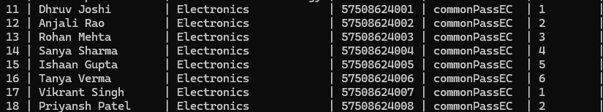
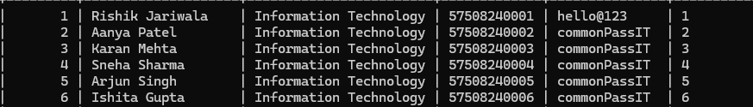
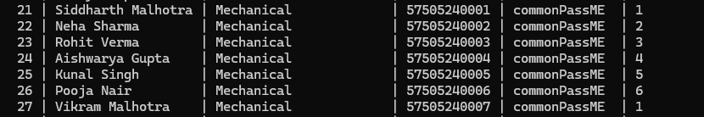
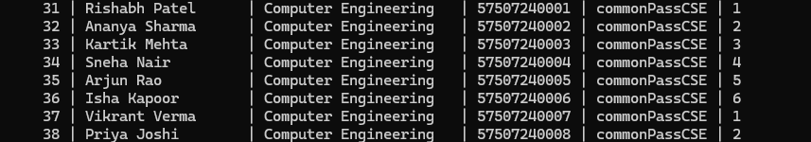
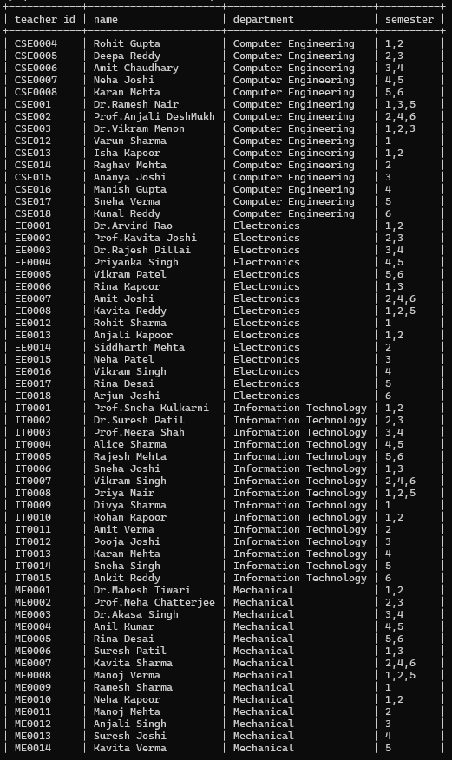
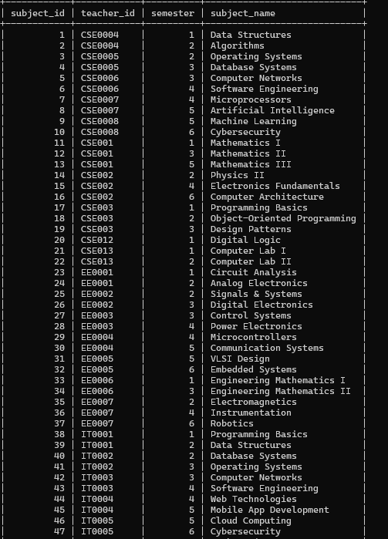
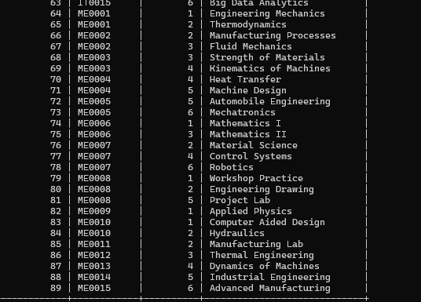
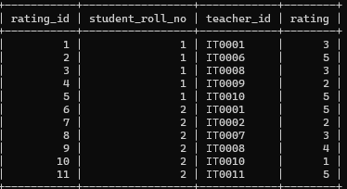
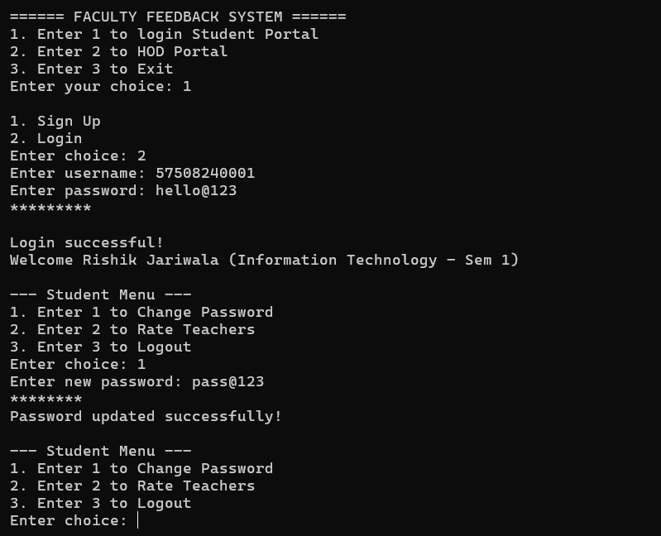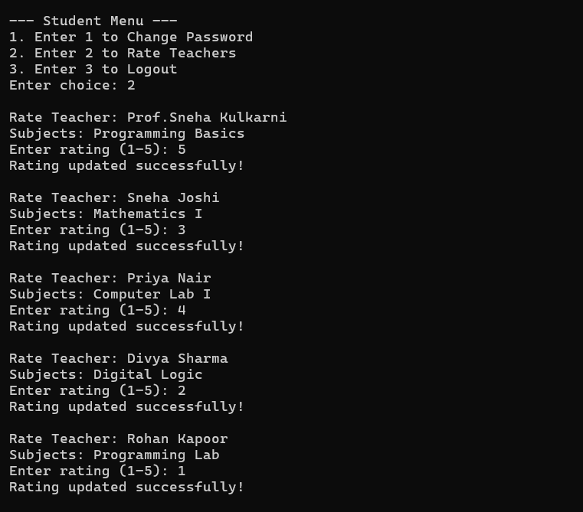
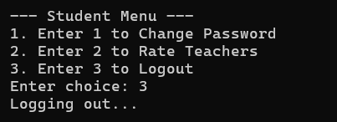
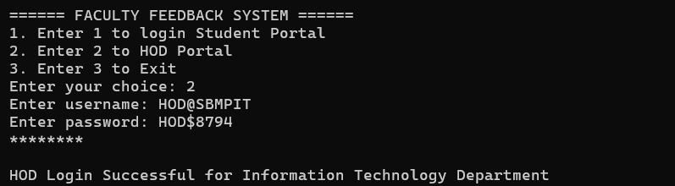
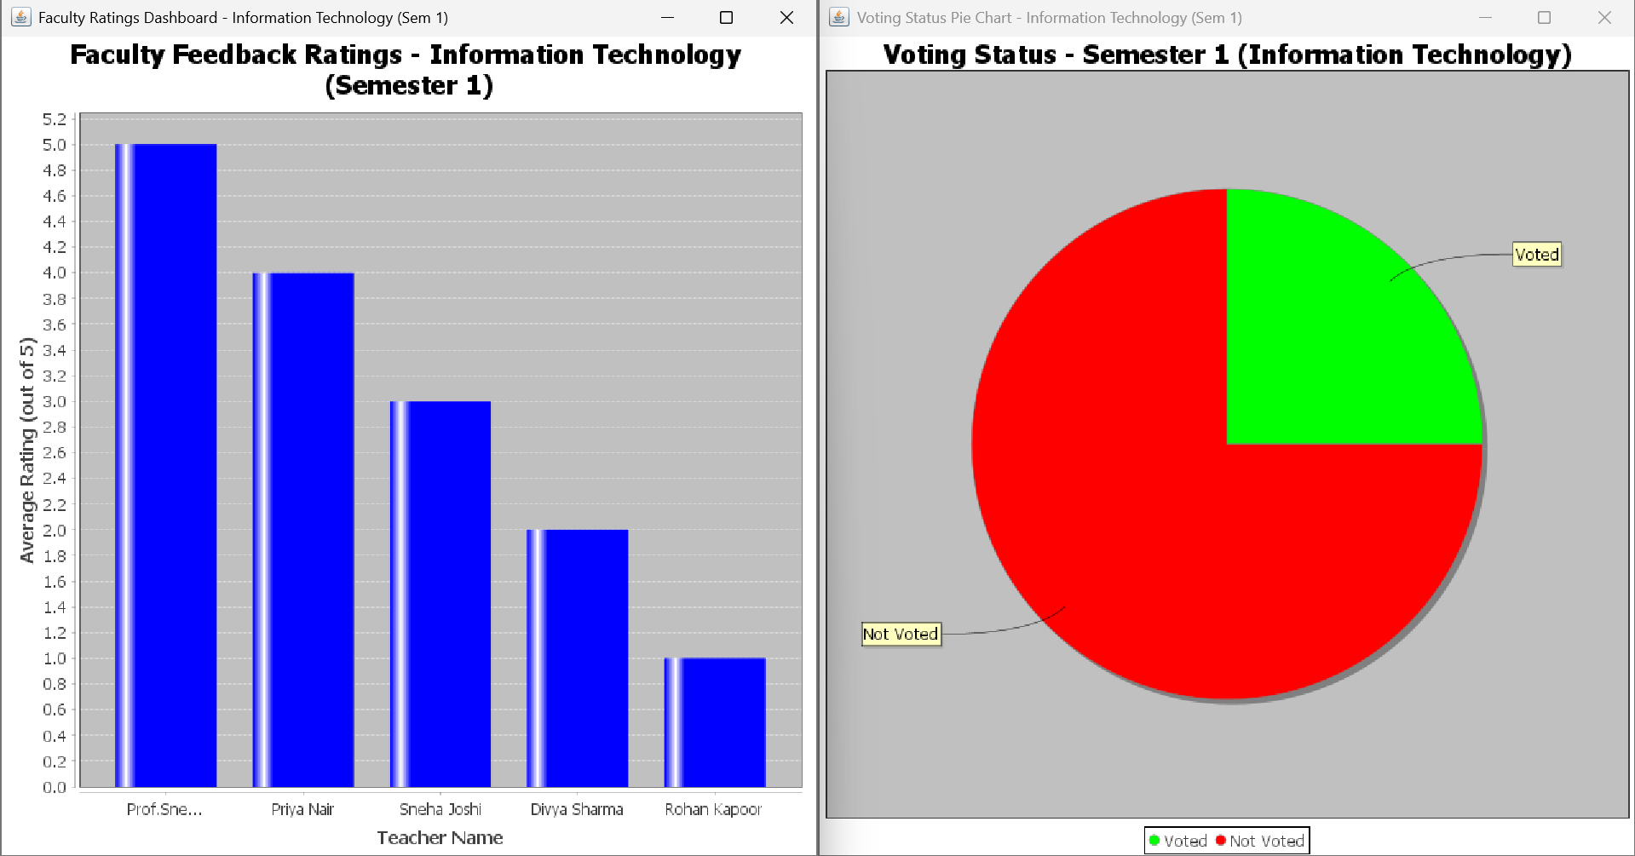
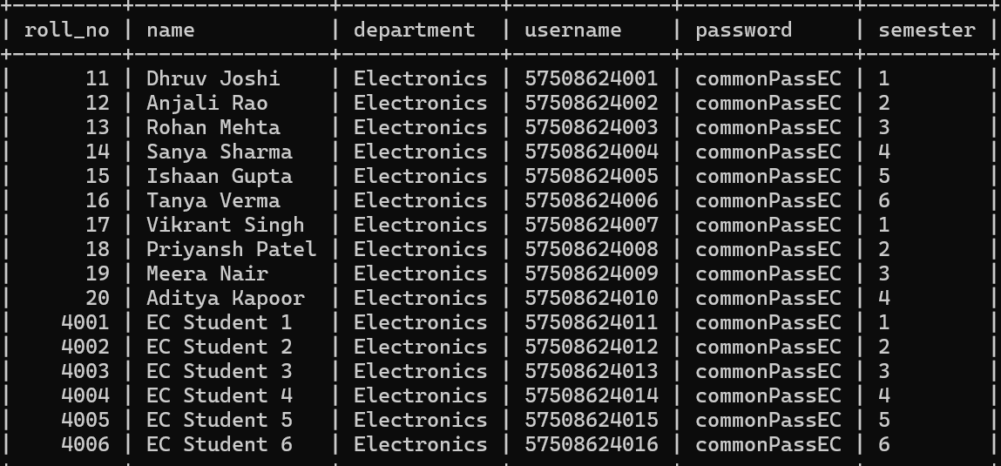
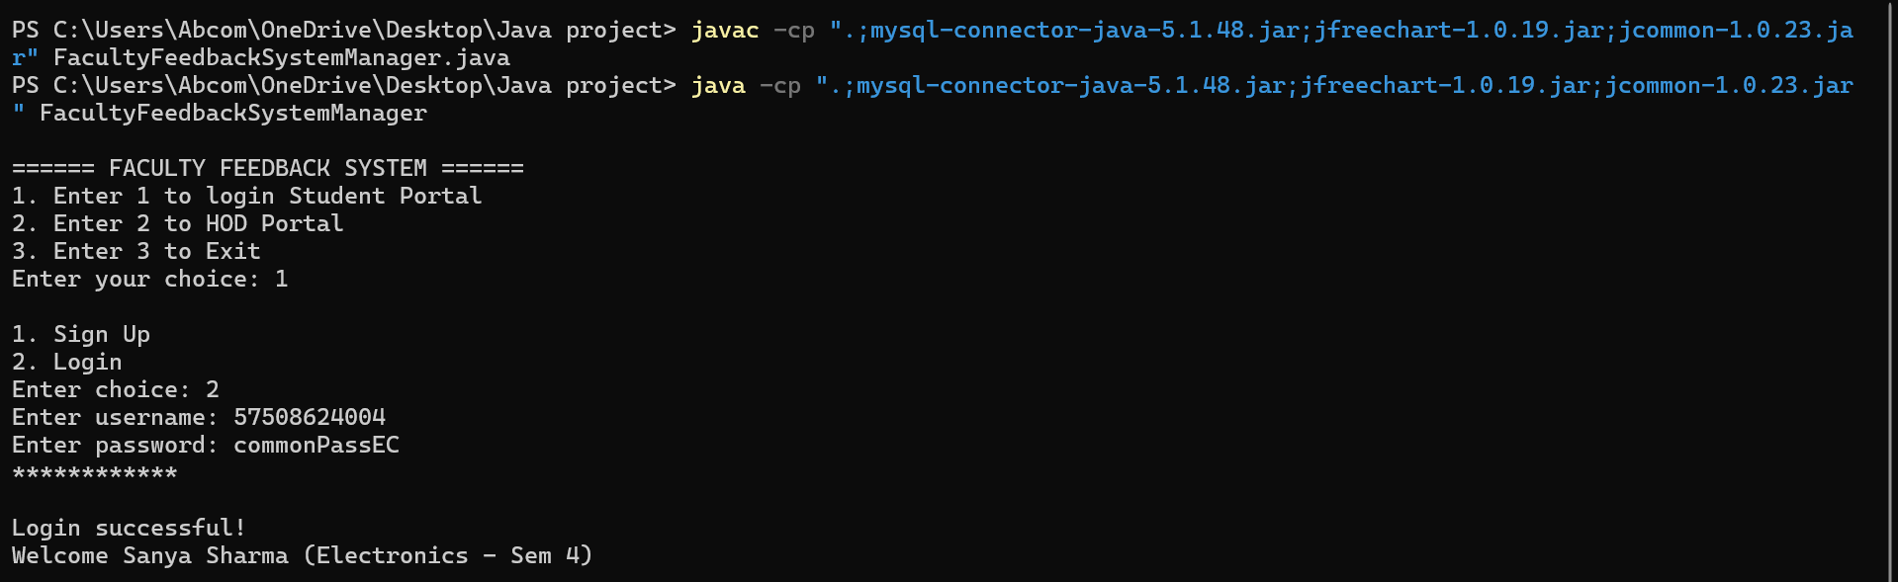
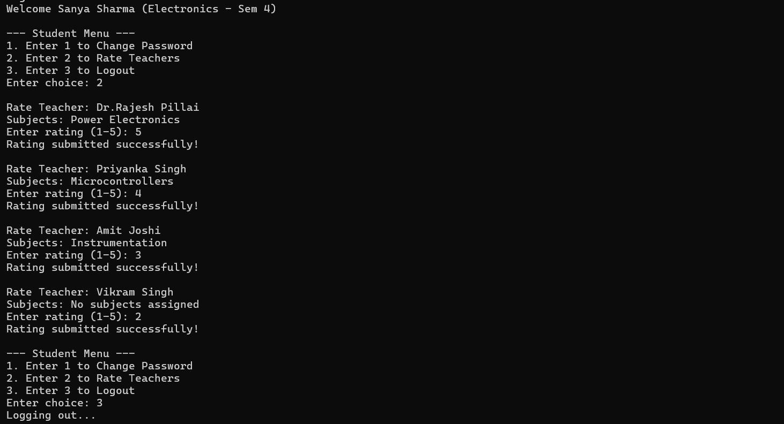
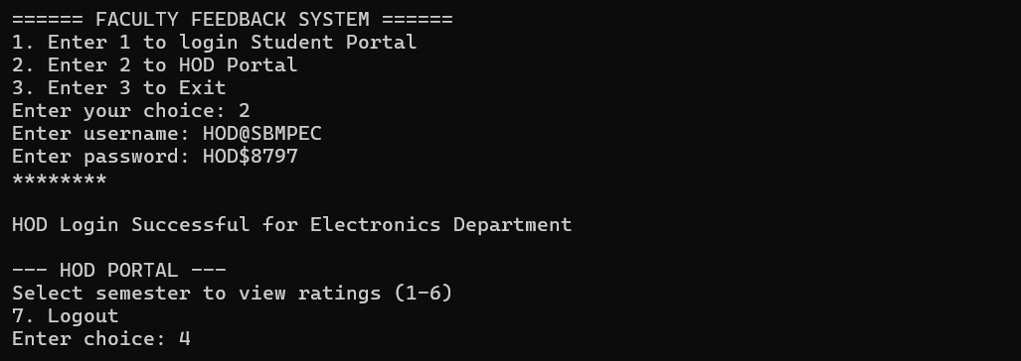
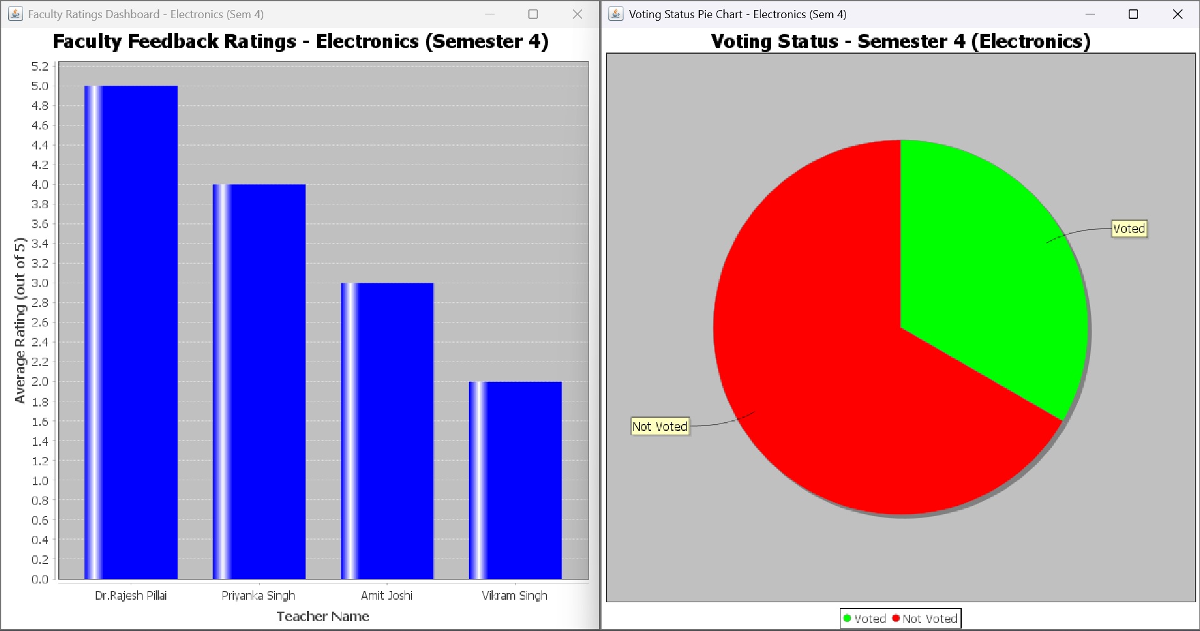
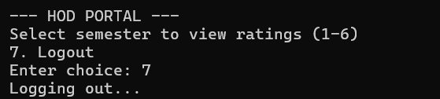
**Output may vary based on login of other departments and ratings given by students of each semester**
Future Scope:
- The entire System can be implemented using the SWING/AWT GUI.
- The teacher having highest Average ratings would be would be recorded by the HOD.
- The source code can be modified such that I tcan be used to create a website by using JAVA SPRINGBOOT.

Conclusion:
- The Faculty Feedback System successfully automates the process of collecting and analyzing student feedback for teachers, making evaluation faster and more transparent.
- It ensures anonymity of students while maintaining accuracy in data collection, encouraging honest responses.
- The system provides visual insights through bar and pie charts, helping the HODs easily identify performance trends of faculty members.
- Overall, this project enhances academic quality by promoting continuous improvement and accountability among teaching staff.

